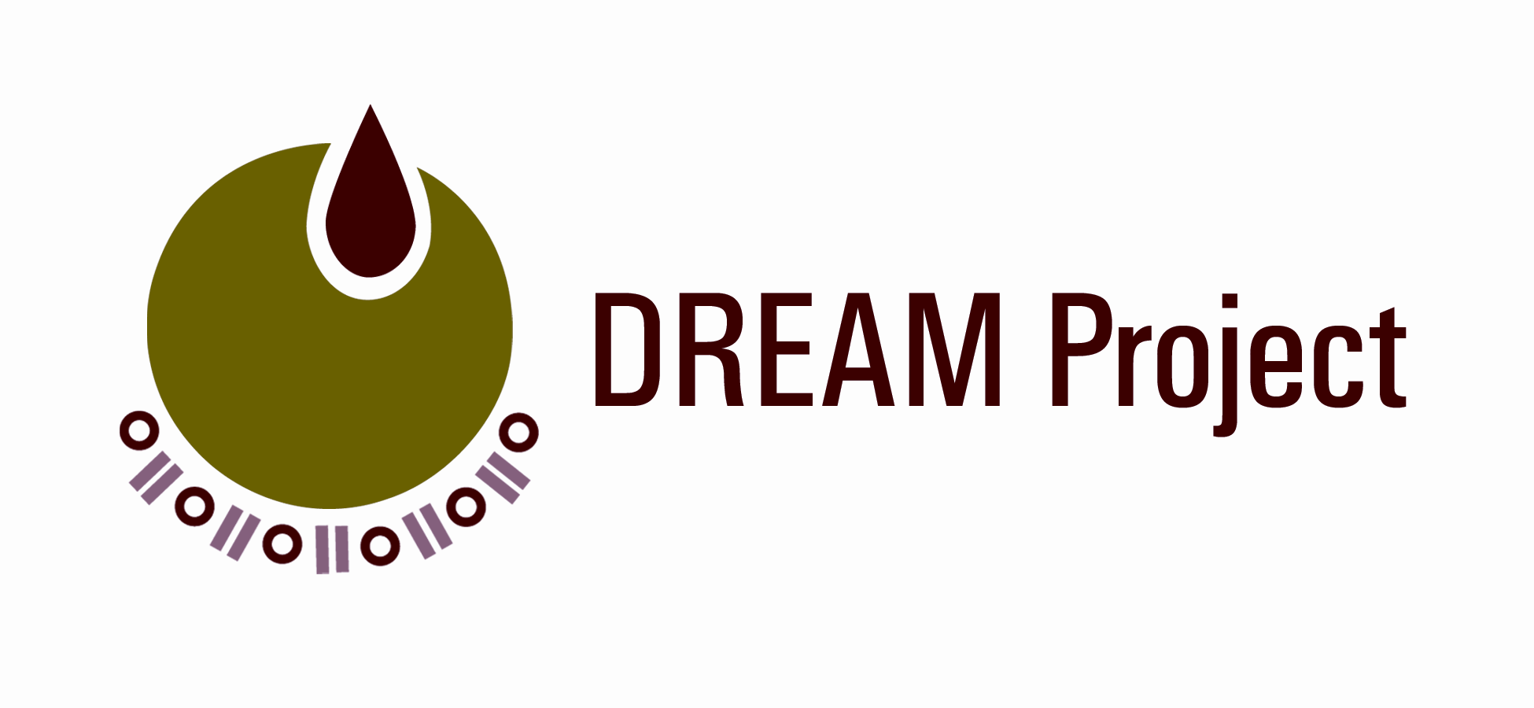
Did you know?
1 out of 4 Bangladeshis in New York City have Diabetes?

ARE YOU A BANGLADESHI WITH DIABETES?
YOU ARE NOT ALONE!

Join the DREAM Project!

The Dream Project is offering a free six month educational and research program for Bangladeshis with Diabetes, taught by Community Health Workers, who are Bangladeshi community members trained on the complications of diabetes.
The DREAM training program covers the following:
- Diabetes and its complication
- Diet & Nutrition
- Exercise
- Family Support
- Stress Management
- How to quit smoking
- And much more…

The DREAM Community Health workers will connect you to a doctor and will help you access other health resources.
So join us in getting healthy for yourself and your family!

For more information contact DREAM Community health workers:
Gulnahar Alam at (212)263-xxxx or Mamnunul Haq at (212)-263-xxxx.

The Diabetes Research Education and Action for Minorities (DREAM) Project is a five year research project under NYU Langone Medical Center for the Study of Asian American Health.

